COIT20265: Networks and Information Security Project

Assessment 1 Part A

Submitted to:
Unit coordinator:
Biplob Roy

Mentor:
Ahmedi Azra

Submitted by:
Md Yeakub 12289551
Tahmid Nizam Ibnul 12277037
Nafisa Sultana 12289859
Muhtasim Mahmud Mahin 12282912

Date of submission
30 March 2026

Table of Contents
Abstract 2
Project Background and justification 2
Problem Statement and Project Objectives 3
Problem Statement 3
Project Objectives 3
Innovative aspects of proposed solution 4
Project scope, assumptions and constraints 4
Scope 4
Assumptions 5
Constraints 5
High-level requirements overview 5
Functional Requirements 6
Non-Functional Requirements 6
Work decomposition 8
Delivery roadmap 9
Risk identification and mitigation plan 11
Potential Risks 11
Strategies to Manage Risks 12
Quality considerations 13
Team structure, roles, and responsibilities matrix 14
Team Roles 14
Responsibilities Matrix 15
Task leads for major deliverables 16
Major Deliverables and Task Leads 16
Required tools and resources 17
Overall Cost Summary 18
Conclusion 18
References 19

An NLP-Based Prototype for Anomaly Detection in Cloud-Generated and Benchmark Cybersecurity Logs

Abstract
The administrators of modern organizations have a big volume of cybersecurity logs data produced by cloud-based systems, and it is hard to manually detect suspicious actions. There is a bigger challenge in identifying anomalies in this data as the number of systems increases and when advanced rule-based systems cannot recognize more complex/changing patterns. The current project is a proposal for a Natural Language Processing (NLP)-based prototype, which takes log data in the form of text and processes it to detect abnormal behavior. The system consists of the following stages: data preprocessing, text normalization, NLP representation with the help of such techniques as TF-IDF or embeddings, and anomaly detection. A triage layer is also added to prioritize suspicious incidents on the basis of their intensity. In general, the suggested solution will contribute to the efficiency of log analysis, decrease manual work, and assist in faster and more efficient cybersecurity monitoring.

Project Background and justification
Cloud servers, web applications, logins, and backend services are used daily in the modern organization. Such systems generate log data at a volume i.e. login attempts, failed access, service activity, system errors, and process events. They are also significant in cybersecurity as the logs are used to trace the activities occurring within the system and may reveal indicators of suspicious or dangerous activity.
The point is that people have excessive log data that requires checking. Security administrators can not individually go through all the records, particularly when the normal operations and suspicious activity co-occur within a record. The larger and more cloud services are used by organizations, the bigger and more difficult to manage the amount of data is.
It is possible that the cyber threats will occur in various manners. An instance is to have several unsuccessful logins, which could indicate a brute force attack. Patterns of strange events can display suspicious activity. A security problem can also be indicated by unexpected behavior of the server or application. Bearing in mind that such logs can be text-intensive and they might not be entirely structured, it might not be sufficient to do simple checks using keywords or rather give fixed rules.
The usefulness of this project is that it addresses a real issue in contemporary organizations, which is the necessity to process large volumes of cybersecurity logs in an efficient way and enable the administrators to detect dangerous activity sooner. A prototype based on NLP is appropriate since it takes logs in the form of text which can be cleansed, tokenised and analysed to identify patterns. This endows the project with practical significance and definite scholastic importance.

Problem Statement and Project Objectives

Problem Statement
Cloud-based Linux servers, applications, authentication systems, and other similar services used by modern organizations produce enormous amounts of cybersecurity logs. Within these logs, unusual behaviors patterns like frequent failed logins, odd event patterns and suspicious server logs, may be hard to locate by hand. The more conventional monitoring systems tend to rely on pre-established rules or naive thresholds, which are not always effective in cases when there are changes in the log data in its wording, structure or sequence.

The gap that this project aims to solve is lack of a viable prototype that can process cloud-generated and benchmark cybersecurity logs in text format and identify glaring behaviors, and generate useful alert contents to the administrator in an efficient and scalable manner.

Project Objectives
The objectives of this project are:
- to gather logs of a Linux based cloud server setup.

- to integrate cloud generated logs with benchmark cybersecurity datasets.

- to tokenize, clean and preprocess textual log data.

- to create an NLP-based prototype of anomaly detector.

- to determine suspicious activity like recurring unsuccessful logins and unusual sequence of events.

- to produce alert-centered outputs on administrators.

- to estimate the prototype based on the measures of precision, recall, F1-score, FP, and processing time.

Innovative aspects of proposed solution
The innovation of the given solution lies in the fact that it considers cybersecurity logs not merely as structured machine records, but as a text too. This enables the system to extract patterns and meaning of log messages that might be overlooked by simple rule-based methods.
The second significant characteristic is the usage of both cloud-generated logs and benchmark datasets. Logs generated by the cloud are more realistic and allow making the project closer to practice, whereas the benchmark datasets are used to assist the stronger testing and comparison.
The solution is also practice oriented. It does not attempt to create a complete enterprise security platform but on a single useful action namely flagging suspicious log behaviour automatically so that administrators are able to concentrate on more dangerous events with less effort.

Project scope, assumptions and constraints

Scope
This project is limited to a cloud-based environment. The logs will be gathered or created on a cloud server based on Linux and analyzed along with benchmark cybersecurity data. The tasks comprise the collection of logs, preprocessing, tokenization, anomaly detection, the generation of alerts, and performance evaluation.

The project will not have live implementation in an actual organization, automated incident response, full size streaming infrastructure, and at large SIEM replacement. It will also only look at a few suspicious actions, including failing to log in several times and unusual patterns of events.

Assumptions
The project presupposes that a Linux-based cloud server can be deployed to facilitate controlled log generation, appropriate benchmark cybersecurity datasets are purchased, and enough computing resources on a prototype level are required to do development and testing.

Constraints
The project constraints are time, team size, computing resources, and the quality of available log data. The scope must remain narrow and controllable because there will be noise and inconsistency in cybersecurity logs.
The overall system architecture is shown in Figure 1.
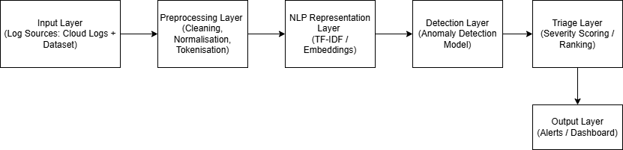
Figure 1: System Architecture Diagram
This diagram shows the layered architecture of the proposed NLP-based system, including input, preprocessing, NLP representation, anomaly detection, triage, and output layers for cybersecurity log analysis.

High-level requirements overview

Functional Requirements
The system shall:
- log traces of Linux based cloud system and testing data.
- clean raw loggings and make it normalized.

- break up log into tokens to be analyzed.

- transform logs into machine read formats.

- identify anomaly of log entries or event sequence dots

- generate anomaly signals, labels of suspicious events, or indicators of alert.

- flagged results display or store results to be reviewed by the administrator.

- support assessment of the system performance based on the chosen metrics.

Non-Functional Requirements
- Performance
The prototype is expected to be capable of processing log datasets of prototype scale within a reasonable time.

- Availability
Testing and demonstration should not require the system to be closed down.

- Scalability
The design must have the capacity to handle increase in log volumes in the future.

- Usability
Outputs must be concise and comprehensible by the technical users like the administrators.

- Reliability
The prototype must also be stable and able to operate without crashing regularly.

- Maintainability
The system must be able to be updated with preprocessing, detection and output modules being updated independently of each other.

- Security
The prototype environment should be safe in dealing with log data.

The workflow of the proposed system is illustrated in Figure 2.
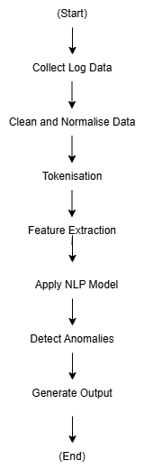
Figure 2: Stepwise process for log data and anomaly collection
This diagram illustrates the step-by-step process of the system, from log data collection through preprocessing and NLP analysis to anomaly detection and output generation.

Work decomposition
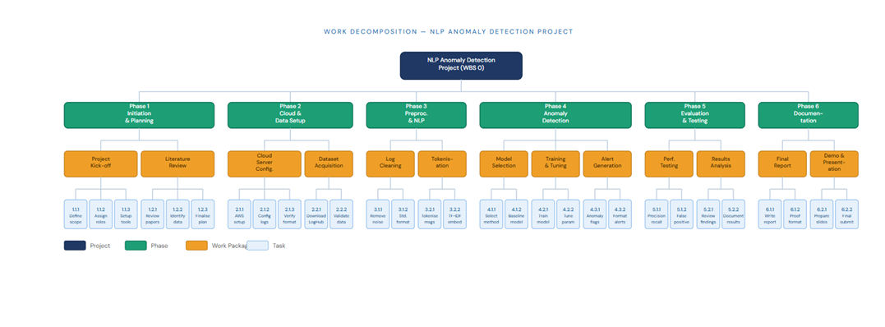Figure 3: Breakdown of work for NLP Anomaly Detection
Figure 3 shows the Work Breakdown Structure (WBS) for the NLP anomaly detection project. This diagram breaks the whole project into smaller phases, work packages, and tasks so the overall work is easier to organise and manage. The project starts at the top as one main goal, and then it is divided into six major phases.
Phase 1:
Initiation and Planning focuses on starting the project properly. This phase includes the project kick-off and the early planning tasks such as defining the project scope, assigning roles, and setting up communication and tracking methods. It also includes the literature review, where relevant NLP-based log analysis papers are reviewed, benchmark datasets are identified, and the final technical direction is decided. This phase is important because it builds the foundation for the rest of the project.
Phase 2:
Cloud and Data Setup focuses on preparing the technical environment and collecting the required data. In this phase, the cloud server is configured, log generation services are set up, and the quality of the generated logs is checked. At the same time, benchmark datasets are collected and validated. This phase makes sure that both the system environment and the datasets are ready before the actual data processing begins.
Phase 3:
Preprocessing and NLP Pipeline focuses on preparing the raw logs for analysis. This includes cleaning the logs by removing noise and irrelevant entries, standardising the format, tokenising the log messages, and applying text representation methods such as TF-IDF or embeddings. This phase is necessary because raw log data is usually inconsistent and cannot be used directly for model training.
Phase 4:
Anomaly Detection is the main development stage of the project. In this phase, the model is selected, a baseline method is implemented, and the system is trained and tuned using the processed log data. It also includes generating anomaly flags and formatting outputs as alerts. This phase is the core of the project because it turns the processed log data into a working anomaly detection solution.
Phase 5:
Evaluation and Testing focuses on checking how well the model performs. This includes performance testing using measures such as precision, recall, and F1-score, as well as analysing false positives and reviewing the results. This phase helps confirm whether the model is reliable enough for the intended purpose.
Phase 6:
Documentation is the final stage of the project. It includes writing the final report, reviewing and formatting it, preparing presentation slides, and completing the final demo and submission. This phase is important because it brings together the technical work and presents it in a clear and complete form.
Overall, the WBS shows the full structure of the project in a clear way. It helps explain how the work moves from planning, to setup, to development, testing, and final delivery.

Delivery roadmap
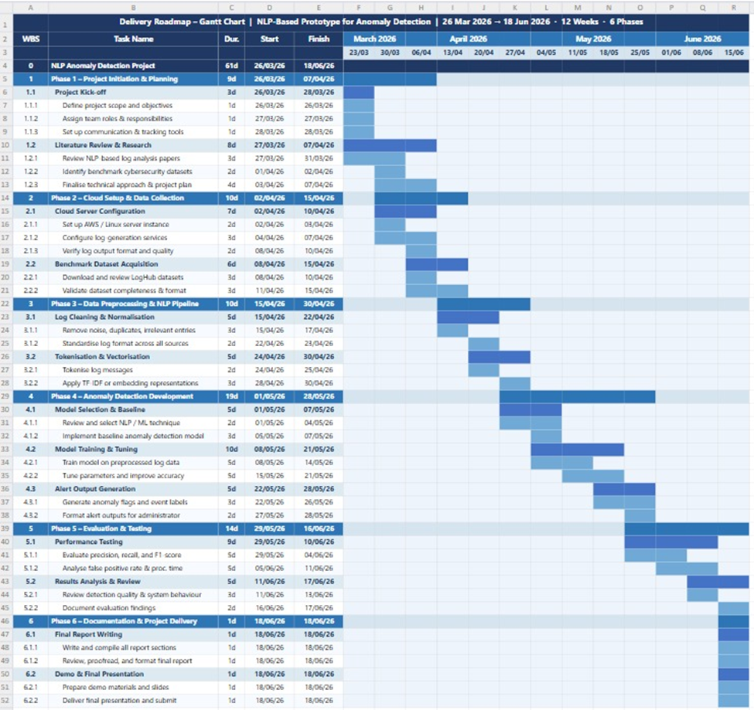Figure 4: Gantt Chart of phase-wise implementation and delivery
Figure 4 presents the delivery roadmap of the NLP anomaly detection project in the form of a Gantt chart. While the WBS shows how the project is divided into tasks, this roadmap shows when each phase and task is planned to happen across the project timeline. The schedule runs from 26 March 2026 to 18 June 2026 across 12 weeks.
Phase 1: Project Initiation and Planning
  - Covers project kick-off and literature review.
  - Focuses on defining scope, roles, and planning tasks.
Phase 2: Cloud Setup and Data Collection
  - Covers cloud server setup and dataset collection.
  - Includes configuring the log generation environment.
Phase 3: Data Preprocessing and NLP Pipeline
  - Covers log cleaning, normalisation, and tokenisation.
  - Prepares the log data for modelling.
  - Takes place after data setup is completed.
Phase 4: Anomaly Detection Development
  - Covers model selection, baseline building, training, and tuning.
  - Includes generating anomaly alerts.
Phase 5: Evaluation and Testing
  - Covers performance testing and result analysis.
  - Includes checking measures such as precision, recall, and F1-score.
Phase 6: Documentation and Project Delivery
  - Covers final report writing and presentation preparation.
  - Includes final submission tasks.
Overall, the delivery roadmap shows a clear and well-organised project schedule, where each phase follows a logical order from planning to final delivery.

Risk identification and mitigation plan

Potential Risks
Risk 1: Not Enough Useful Log Data
The generated cloud logs may be too limited for meaningful anomaly detection.
Risk 2: Preprocessing Takes More Time Than Expected
Cybersecurity logs may be noisy, semi-structured, and inconsistent, which can make preprocessing difficult.
Risk 3: Weak Model Results
The anomaly detection model may produce low accuracy or too many false positives.
Risk 4: Scope Becomes Too Wide
Including too many threat types, platforms, or features may make the project too difficult to complete.
Risk 5: Cloud Setup Problems
Issues with server configuration, permissions, or log generation may delay progress.
Risk 6: Team Coordination Issues
Unclear roles or uneven workload may affect progress and delivery.

Strategies to Manage Risks
In small log data, the project will involve cloud generated logs as well as benchmark datasets. This will provide a greater diversity in the data and aid in the testing.
To simplify preprocessing issues, the project will constrain the number of sources of logs and establish a distinctive preprocessing pipeline at the outset of the development.
In the case of poor model performance, a simple baseline will be used initially, the results will be analyzed, preprocessing and text representation will be optimized, and then more complexity will be added.
To address scope problems, the project will remain narrow on the use of cloud-hosted Linux logs and the chosen cases of anomalies (as failed repetitive logins and unusual sequences of events).

A basic Linux cloud infrastructure will be employed in case of cloud set up issues. Preparation of benchmark datasets will also be done concurrently to enable work to proceed even in case setup will take more time.
In case of team coordination, the roles and task leaders will be determined in advance, and the progress will be monitored with the help of the frequent communication.
The identified risks and their impact levels are summarized in Figure 3, while detailed risk information is presented in Figure 5.

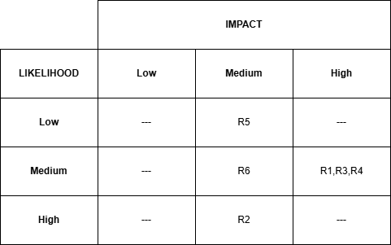
Figure 5: Risk Severity Matrix
This matrix illustrates the relationship between the likelihood and impact of identified risks, helping to prioritize risk management activities within the project.

Risk ID | Risk Description | Likelihood | Impact | Mitigation Strategy
R1 | Not enough useful log data | Medium | High | Use cloud-generated and benchmark datasets
R2 | Preprocessing takes more time than expected | High | Medium | Limit log sources and design preprocessing pipeline
R3 | Weak model results | Medium | High | Start with baseline and improve results
R4 | Scope becomes too wide | Medium | High | Focus on selected anomaly types
R5 | Cloud setup problems | Low | Medium | Use simple Linux setup and backup datasets
R6 | Team coordination issues | Medium | Medium | Assign roles and maintain communication
Table 1: Risk Register
This table summarizes the identified project risks, their likelihood and impact levels, and the corresponding mitigation strategies.

Quality considerations
In this project, quality would be assessed by the technical performance and usefulness in practice.
Functional Quality
The prototype must also be able to accomplish the entire process of working through the log input to anomaly related output without significant failure.
Detection Quality
Precision, recall, F1-score, false positive rate, and processing time will be used to investigate the system.
Usability Quality
The results should come out clearly with suspicious events to make the administrators understand the results easily.
Reliability and Stability
There should also be no frequent crashes or broken workflow steps when the system is tested and demonstrated.
Maintainability Quality
The solution must be designed in a modular manner so that they can be later updated easily.

This is a prototype and thus the primary objective is to achieve a working, testable and well built system but not necessarily a complete enterprise product.

Team structure, roles, and responsibilities matrix
The defined team structure is also significant in this project since the project involves planning, setting up clouds, coding, data preparation, testing, and reporting. Allowing everyone to have a primary role keeps the group focused and enables one to keep track of the progress.

Team Roles
Project Manager
The Project Manager takes care of scheduling, planning and general coordination. This individual keeps the team on its path, ensures that things are done in time and also ensures that the project remains focused towards its objectives.
Cloud Engineer / Developer
The Cloud Engineer/Developer will be needed to install the Linux-based cloud environment and assist in the creation of the logs required by the project. The technical arrangement of the data collection and preparation is also handled in this position.
Software Engineer
The Software Engineer assembles the main prototype and links the various components of the system. This involves the addition of logs, processing, and the output or display of an alert.
Data Analyst / NLP Developer
The Data Analyst or NLP Developer puts together the data, cleans and tokenizes the logs, forms the system of anomaly detection, and monitors the functionality of the system.

Responsibilities Matrix
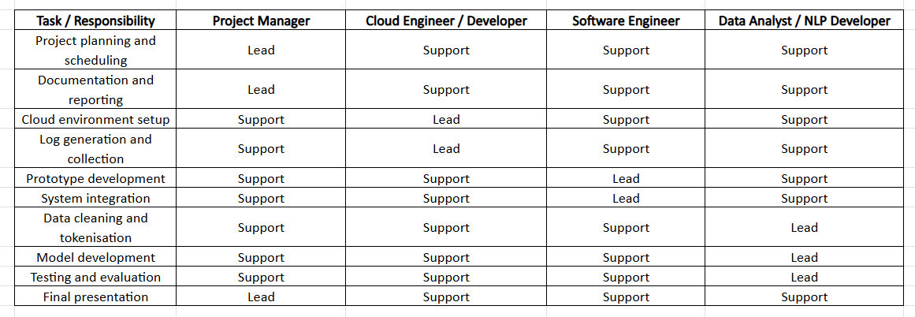Figure 7: Responsibility matrix
Figure 7 presents the responsibility matrix for the project team. It shows the main project tasks and identifies which team member takes the lead role and which members provide support. This helps make task ownership clear, improves coordination, and reduces confusion during the project. It also ensures that each major activity, from planning and cloud setup to model development, testing, and final presentation, has clear responsibility assigned within the team.

Task leads for major deliverables
The table below shows the main team roles, the person assigned to each role, and their main responsibilities in the project. Defining roles clearly helps the team divide the work properly, reduce confusion, and make sure each part of the project has someone accountable for it.
Stakeholder Role | Assigned Person | Responsibility
Project Manager | Tahmid | Manages the project plan, team coordination, progress tracking, and final deliverables.
Cloud Engineer | Mahin | Prepares the cloud setup, manages servers, and supports log generation and system setup.
Software Engineer | Nafisa | Develops the prototype, integrates system components, and supports anomaly detection implementation.
Data Analyst | Yeakub | Collects, cleans, and prepares data, and helps evaluate model performance.
Table 2: Assigned Roles
Each major deliverable should have one main person in charge. This makes it easier to manage the work and avoids confusion about who is responsible for what it is.

Major Deliverables and Task Leads

Project proposal and report writing – Project Manager
The project manager will lead the writing and organization of the proposal and make sure all sections are completed properly.

Cloud setup and log generation – Cloud Engineer / Developer
This person will take care of setting up the cloud server and making sure useful log data is collected.

Prototype development and system integration – Software Engineer
The software engineer will lead the building of the prototype and connect all parts of the system, so they work together.

Data preparation and anomaly detection model – Data Analyst / NLP Developer
This role will handle data cleaning, tokenization, model building, and the analysis of the side of the project.

Testing and performance evaluation – Data Analyst / NLP Developer
With support from the Software Engineer and this part includes checking how well the system works and measuring results using the chosen performance metrics.

Final demo and presentation – Project Manager
With support from the full team, the Project Manager will organize the final presentation, while each team member will explain the part they worked on.

Required tools and resources
Hardware
- laptops or desktop computers
- stable internet connection
Cloud and Server Resources
- AWS or another cloud platform
- Linux-based cloud server instance
Software Tools
- Python
- Jupyter Notebook or VS Code
- Git and GitHub
- NLP, machine learning, and data analysis libraries
Data Resources
- cloud-generated server logs
- benchmark cybersecurity log datasets
Evaluation Resources
- tools for measuring precision, recall, F1-score, false positive rate, and processing time
These resources are manageable for a capstone project because they mainly rely on common cloud tools, open-source software, and standard development platforms.

Overall Cost Summary

Phase | Main Cost Items | Estimated Cost (AUD)
Phase 1: Initiation and Planning | Project planning, literature review, meeting and coordination time | 300
Phase 2: Cloud Setup and Data Collection | Cloud server usage, storage, log generation setup, dataset preparation | 600
Phase 3: Data Preprocessing and NLP Pipeline | Data cleaning, preprocessing tools, development time | 400
Phase 4: Anomaly Detection Development | Model development, training, tuning, software setup | 300
Phase 5: Evaluation and Testing | Testing, performance evaluation, result analysis | 350
Phase 6: Documentation and Project Delivery | Report preparation, presentation slides, final demo and submission work | 250
Total Estimated Cost |  | 2,200
Table 3: Expected cost for overall phase
The table shows the estimated cost for each phase of the project. The highest cost is expected in the anomaly detection development phase because it involves the main technical work, including model building, training, and tuning. Lower costs are assigned to planning and documentation phases because they mainly involve coordination, writing, and reporting activities.

Conclusion
In this project, the design and intended development of an NLP-based prototype of detective anomalies in cloud-generated and benchmark cybersecurity logs are presented. The proposal deals with one of the most urgent issues of contemporary organizations, which is the problem of detecting suspicious behavior amidst high volumes of semi-structured log information. The project uses the more flexible and smart approach to handling log data in place of more traditional rule-based systems by processing log information such as text, tokenization, and feature representations to incorporate NLP techniques.
In terms of IT project, the proposal is a clear and viable plan and addresses all critical stages of the project, such as planning, cloud deployment, data preprocessing, model development, evaluation, and final delivery. The scope, clear objectives, and realistic constraints will ensure that the project is within the means of the set time limits and resources. The aspect of risk management strategy, quality concerns, and the team organization based on the roles also increases the feasibility and organization of the project.
In addition, the combination of both the cloud-generated logs and the benchmark datasets help to increase the reliability and testing capacity of the prototype, and the use of the evaluation metrics like precision, recall, and F1-score provides the possibility to evaluate the performance in measurable ways. The project will reduce the number of manual efforts required by the administrators; it will also lead to the acceleration of timely and efficient cybersecurity monitoring.
In general, the given project is a significant demonstration of the IT knowledge application to real-life cybersecurity issues. Although it is restricted to the prototype stage, it provides a solid base on how it can be enhanced in the future, e.g. scaling the system, adding real-time processing or turning it into an actual security monitoring system. The project has been able to blend technical implementation, project management practices, and practice relevance which make it a good learning experience and a worthy contribution to the subject of cybersecurity analytics.

References
Beck, V., Landauer, M., Wurzenberger, M., Skopik, F., & Rauber, A. (2025). SoK: LLM-based log parsing [Preprint]. arXiv. https://arxiv.org/abs/2504.04877
Globerson, S. (1994). Impact of various work-breakdown structures on project conceptualisation. International Journal of Project Management, 12(3), 165–171. https://doi.org/10.1016/0263-7863(94)90007-8
Guan, W., Cao, J., Qian, S., Gao, J., & Ouyang, C. (2024). LogLLM: Log-based anomaly detection using large language models [Preprint]. arXiv. https://arxiv.org/abs/2411.08561
Haugan, G. T. (2002). Effective work breakdown structures. Management Concepts.
Kerzner, H. (2022). Project management: A systems approach to planning, scheduling, and controlling (13th ed.). John Wiley & Sons.
Lu, J., & Wu, C. (2024). TPLogAD: Unsupervised log anomaly detection based on event templates and key parameters [Preprint]. arXiv. https://arxiv.org/abs/2411.15250
Tan, Z., Wang, Q., Anagnostopoulos, C., Parambath, S. P., Singer, J., & Temple, S. (2025). Distributed log-driven anomaly detection system based on evolving decision making [Preprint]. arXiv. https://arxiv.org/abs/2504.02322
Wilson, J. M. (2003). Gantt charts: A centenary appreciation. European Journal of Operational Research, 149(2), 430–437. https://doi.org/10.1016/S0377-2217(02)00769-5
Zhu, J., He, S., He, P., Liu, J., & Lyu, M. R. (2023). LogHub: A large collection of system log datasets for AI-driven log analytics [Preprint]. arXiv. https://arxiv.org/abs/2008.06448

